DRILL 6

* **Drill6_1.v**
  + 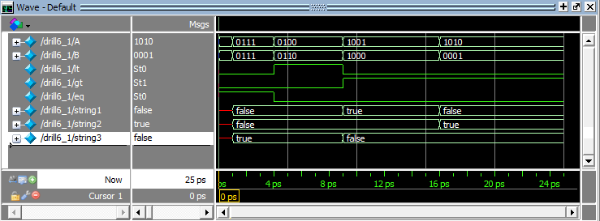Testbench
  + Transcript

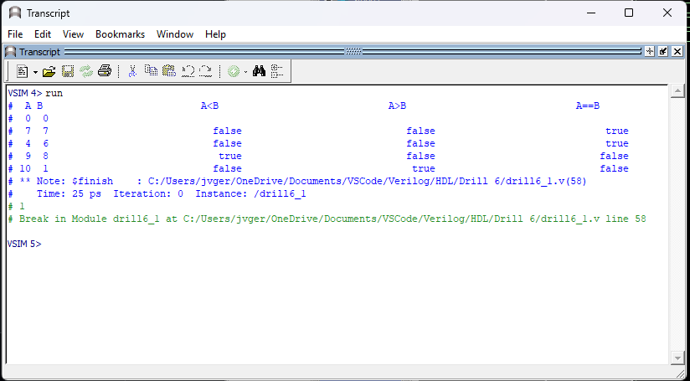

* **Drill6_2.v**
  + 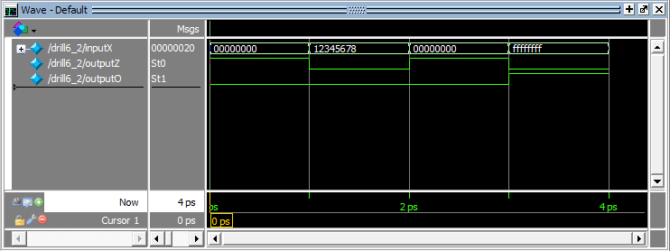Testbench
  + Transcript

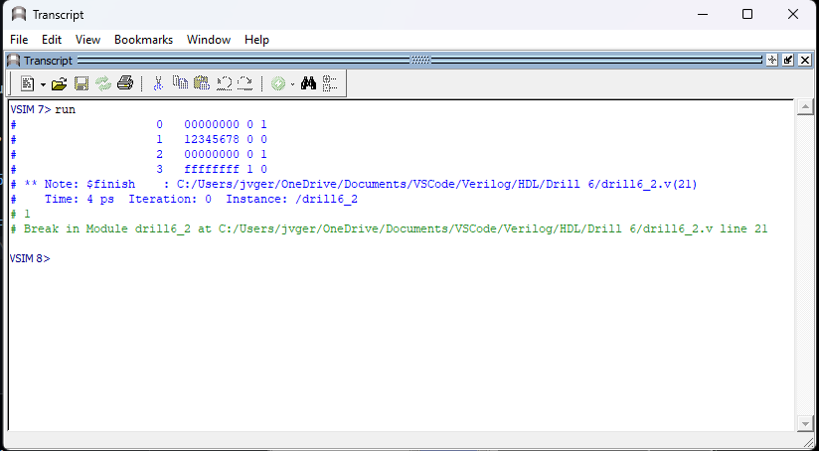

* **Drill6_3.v**
  + 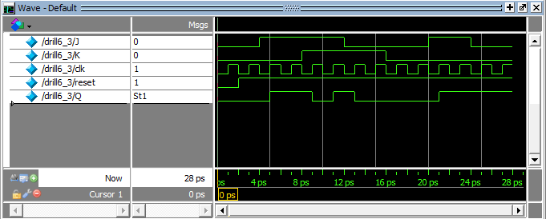Testbench
  + Transcript

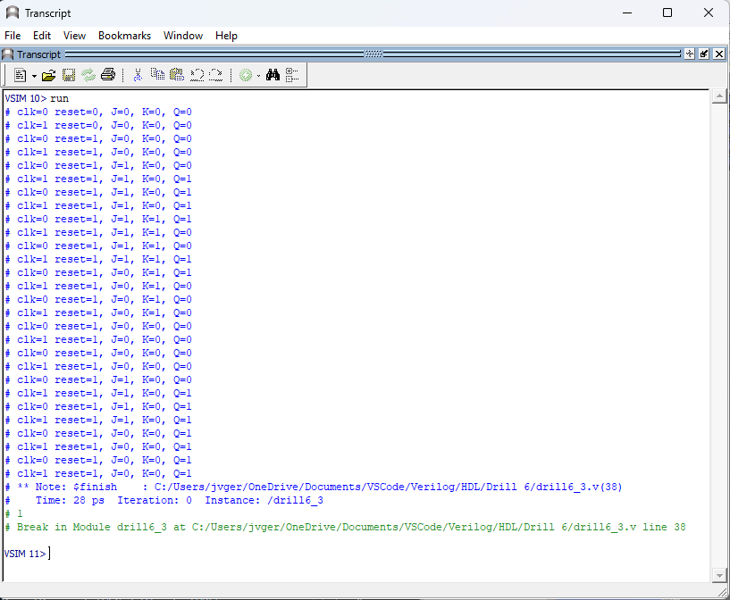

* **Exercise6_1.v**
  + 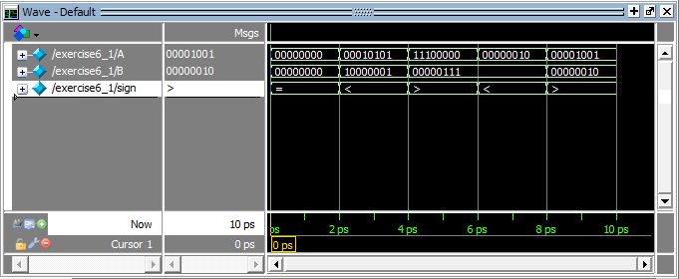Testbench
  + Transcript

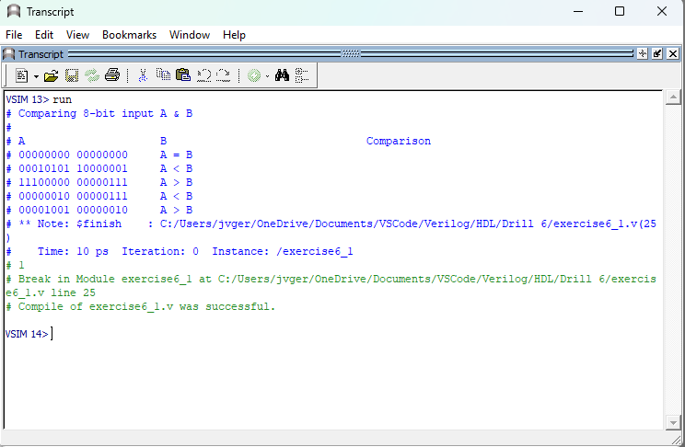

* **Exercise6_2.v**
  + 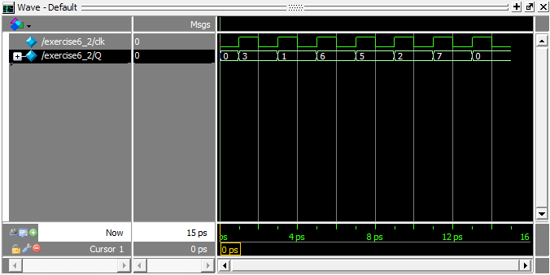Testbench
  + Transcript

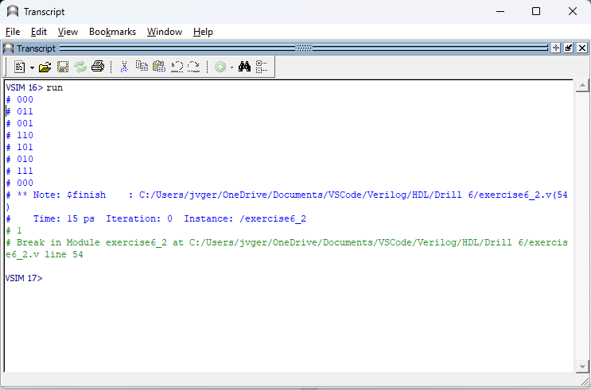

**Review Questions**

1. **Why is dataflow modelling named as such?**

*It is called dataflow because, it focuses on the "data flow" between different parts of the design rather than using sequential blocks or statements.*

1. **Why is continuous assignment in dataflow modelling named as such?**

*Continuous assignment in dataflow modelling is named as such because it assigns values to signals continuously at each given time.*

1. **What is the effect of imposing a dataflow assignment to a nonblocking procedure?**

*The effect of imposing a dataflow assignment to a nonblocking procedure is that it allows the procedure to operate asynchronously and at the same time maintains data flow consistency. This means that operations can be carried out in parallel, increasing both performance and scalability.*